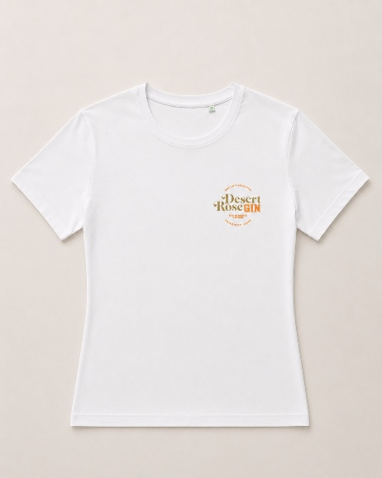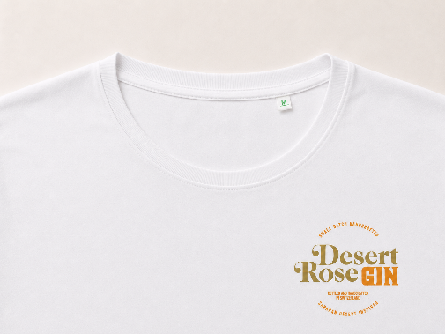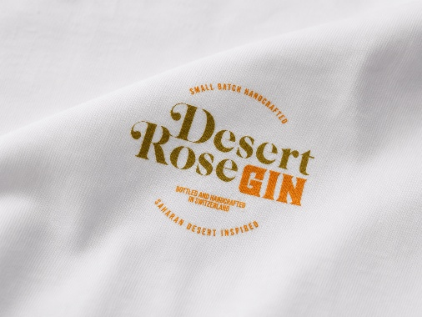
T-Shirt Donna Desert Rose Gin – Cotone Organico
Stylish, comfortable and designed to accompany you on the hottest days, the Desert Rose Gin Women's T-Shirt combines essential style with superior materials.
Made from 100% organic cotton, it feels soft and natural against the skin, while ensuring breathability and comfort throughout the day.
The slightly contoured feminine fit that enhances the silhouette without being tight ensures a perfect balance between elegance and comfort. The classic reinforced crew neck and the refined finishes complete a versatile and durable garment.
On the chest there is the refined Desert Rose Gin logo printed in color, for a discreet yet distinctive look.
Features
- 100% organic cotton
- Slightly contoured feminine fit
- Soft and durable crew neck
- Lightweight and breathable fabric
- Desert Rose Gin logo on the chest
- Color: White
- Essential and elegant design
Available sizes
Available in sizes:
- S
- M
- L
Garment care
- Wash at maximum 30°C
- Wash and iron inside out
- Do not use bleach
- Do not tumble dry
A garment that combines comfort, sustainability and the unmistakable style of Desert Rose Gin, ideal for those who appreciate quality, simplicity and attention to detail.

